Experiment 35
Display Text on an Image using OpenCV
Aim: To display a user-entered text string on an image using OpenCV.
Procedure:
- Import the OpenCV library.
- Read the input image.
- Get a text string from the user.
- Display the text using cv2.putText().
- Save the output image.
Program:

import cv2

img = cv2.imread(r"D:\Amrita\Pictures\Screenshots\Screenshot 2026-09-30 143819.png")

if img is None:
print("Image not found")
else:
text = input("Enter text: ")

cv2.putText(img, text, (50, 100),
cv2.FONT_HERSHEY_SIMPLEX,
1, (0, 0, 255), 2)

result = cv2.imwrite(r"D:\Amrita\Documents\text_output.png", img)

print("Image saved:", result)
Input:
String: hello world
Output:
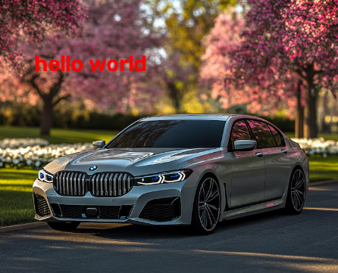
Result: The entered text is displayed on the original image and the modified image is saved successfully.

